Alien Juice Bar Lab - Exploring Acids and Bases
Name ________________________
Hour ______ Lab Station ______
Background
Many substances we use every day can be considered acids or bases. Most are harmless. Some, however, can be dangerous due to their “strength” even though they might be items we have in our own homes. Characteristics of acids include a sour taste, and bases can taste bitter and feel slippery. Not all acids are meant to be consumed. Some can be extremely dangerous in fact, and even burn your skin so it is important to use them wisely and carefully. In order to measure the strength of an acid or base, you use a pH scale like below.
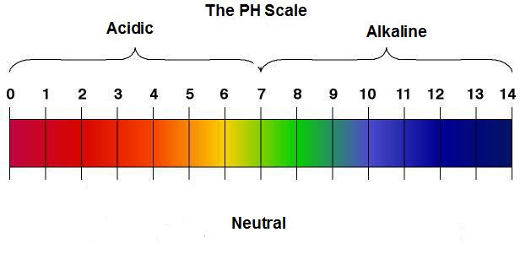

Stronger acids
Stronger bases

The strength of the pH scale is determined by the concentration of hydrogen (H⁺) ions or hydroxide (OH⁻) ions. More hydrogen ions would make an acid and more hydroxide ions would make a base (alkaline). The amount of each determines the strength of the acid or base. The pH scale ranges from 1-14, with 7 being “neutral,” or the same concentration of each. The lower numbers indicate how strong the acid is and the higher numbers indicate how strong the base is.
There are different ways you can measure the strength of an acid or base. You can use the juice from red cabbage as an indicator or pH litmus paper. Depending on the strength of the substance, it will create a color change in the juice or on the litmus paper. You will use both types in this lab to determine the strength of common acids and bases.

Color Scale for Cabbage Juice Indicator:
Color: | Pink | Dark red | Violet | Blue | Blue-Green | Green-Yellow
Approx. pH | 1-2 | 3-4 | 5-7 | 8 | 9-10 | 11-12
Acid/Base | Acid | Acid | Acid/Neutral | Base | Base | Base

Color Scale for Litmus Paper:
**Use the color chart at your lab station.

Materials

Beaker of red cabbage “juice” with pipette
Plastic cups with several liquids to test with pipettes
Clean mixing tray with “wells”
pH litmus paper (from your teacher)
pH color scale
Dixie cup for used (waste) litmus paper

Prelab predictions
Think of each of the liquids that will be tested below. Predict whether you think they will be acidic, neutral, or basic. (think of the properties of acids and bases)

Hand sanitizer acidic neutral basic
Vinegar acidic neutral basic
Shampoo acidic neutral basic
Conditioner acidic neutral basic
Lemon Juice acidic neutral basic
Laundry Detergent acidic neutral basic
Water acidic neutral basic

Instructions
Part a) cabbage juice indicator
1. Please use the pipettes for only the liquids in which they are supposed to be used for. Doing so will contaminate the liquids. Place a piece of white paper under your mixing tray so you can see the colors better.
2. Starting with a liquid of your choice, use the pipette that is in that cup to draw up a sample and slowly squirt it into an empty “well” of the mixing tray to about half full.
3. Use the pipette that is in the beaker of cabbage juice to draw up a small sample and slowly squirt it into the same “well” that now contains a small sample of the liquid you chose. Observe any color change and record in your data table below. Remember to record pH as well!
4. Repeat steps 2-3 for each additional liquid.
5. When you are done testing the liquids, pour them into the sink and rinse your mixing tray well. Turn it upside down on a clean piece of paper towel to dry for the next group.

Part b) litmus paper indicator
6. Get 7 pieces of litmus paper from the teacher. Keep them dry until ready to use.
7. Hold the tip of a piece of litmus paper and dip a corner of it into the cup of a liquid of your choice. Compare the color change to the pH color chart to determine the pH of that liquid. Record the pH number in your data table below. Throw away the used litmus paper in the waste paper cup.
8. Repeat this for all liquids. Make sure your lab station is cleaned up.

Part c) compare to the actual!
9. Check the actual pH of each liquid (see your teacher). Record in your data table. Determine if each liquid is an acid, neutral, or a base. Record in your data table.

Liquid: | Cabbage color/pH | Litmus paper color/ pH | Actual pH | Acid?/Neutral?/Base?
Example | Pink / 2 | Orange / 3 | 2.5 | acid
Hand sanitizer
Vinegar
Shampoo
Conditioner
Lemon Juice
Laundry Detergent
Water

Analysis
1. How did the cabbage juice indicator pH and litmus paper indicator pH numbers compare to each other? Were they similar? different? Give examples to support your answer.

2. Which one (or both) were closer to the actual pH? Give examples to support your answer.

3. Using the litmus paper color scale, which color represents the strongest acid?

The strongest base?

4. What happens to the number scale as an acid gets stronger?

As a base gets stronger?

5. When an acid and a base mix in equal amounts, they neutralize each other. Why would you use an antacid (a base) when you have an upset stomach (too much stomach acid)? Explain.

